

Insurance typically covers AAC devices but understanding your specific plan and demonstrating medical necessity are key for approval. Contact your insurance provider to verify coverage and consult with a speech therapist for assessments and documentation to support your claim.

AAC (Augmentative and Alternative Communication) devices support nonverbal or minimally verbal children.
Types include speech tablets, apps, symbol boards, and more.
- Step 1: Ask your pediatrician or therapist for an AAC referral.
- Step 2: Request a speech-language evaluation.
- Step 3: Work with your insurance or Medicaid plan to cover the device.
Tips: Many clinics and schools offer support with paperwork and justification letters.
Navigating Insurance for AAC Devices:
1. 1. Verify Coverage:
Contact your insurance provider to understand if AAC devices are covered under your plan and if they are classified as Durable Medical Equipment (DME).
2. 2. Documentation:
Be prepared to provide documentation that demonstrates the medical necessity of the device. This usually includes assessments from a speech-language pathologist and a doctor's prescription.
3. 3. Medical Necessity:
Ensure your documentation includes comprehensive assessments, reports, and standardized assessment tools to prove the device is needed for communication and daily functioning.
4. 4. Funding Options:
If insurance doesn't fully cover the cost, explore other options like Medicaid, Medicare, state vocational rehabilitation programs, or grants/scholarships.
5. 5. Consult Professionals:
Work with a speech therapist or assistive technology specialist to navigate the assessment, documentation, and funding process.
Key Considerations:
• Prior Authorization:
Some insurance plans require prior authorization before you can obtain the device.
• Limitations and Exclusions:
Understand any limitations or exclusions in your policy that might affect coverage.
• Annual Limits:
Check if there are any annual limits on coverage for AAC equipment.
• Device Trials:
Some providers offer trial periods with the device at home to ensure it's a good fit before pursuing funding.
• Customization:
AAC devices are often customizable to meet individual needs, so consider personalization options.
• Training and Support:
Ensure you receive adequate training and support to effectively use the device, including communication coaching sessions. 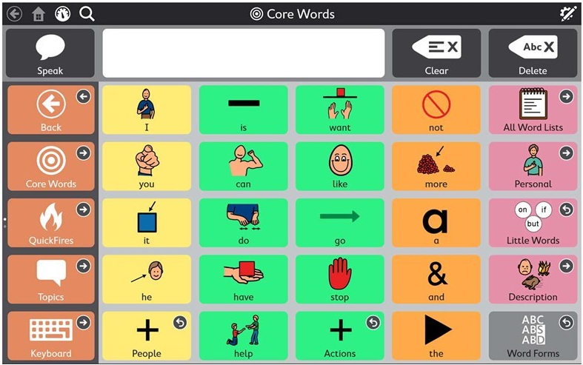
This Photo by Unknown Author is licensed under CC BY-NC-ND
. 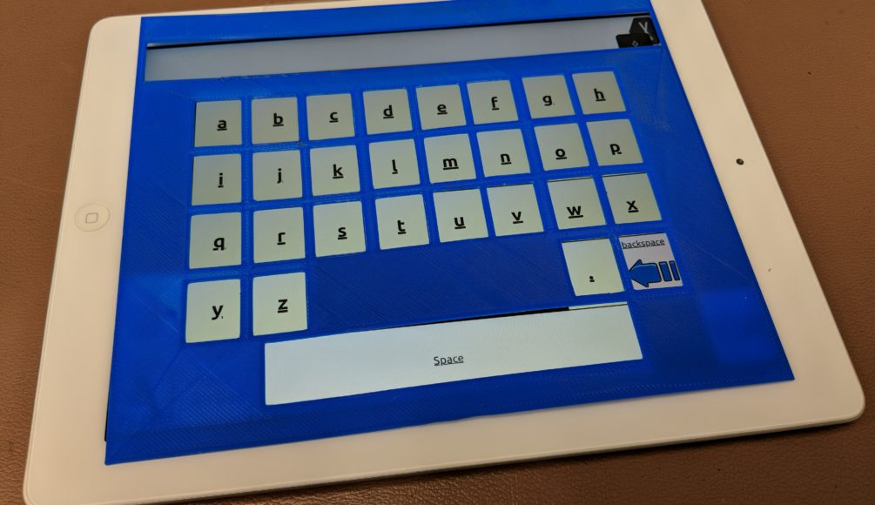
This Photo by Unknown Author is licensed under CC BY-SA

